**Lab 5**

Start PICSimLab. Select the board McLab2. Select PIC16F877A as microcontroller using the micro-controller tab. Configure the microcontroller through your code as follows:

#pragma config FOSC = XT // Oscillator Selection bits (XT oscillator)

#pragma config WDTE = OFF // Watchdog Timer Enable bit (WDT disabled)

#pragma config PWRTE = OFF // Power-up Timer Enable bit (PWRT disabled)

#pragma config BOREN = OFF // Brown-out Reset Enable bit (BOR disabled)

#pragma config LVP = OFF // Low-Voltage (Single-Supply) In-Circuit Serial Programming Enable bit (RB3 is digital I/O, HV on MCLR must be used for programming)

#pragma config CPD = OFF // Data EEPROM Memory Code Protection bit (Data EEPROM code protection off)

#pragma config WRT = OFF // Flash Program Memory Write Enable bits (Write protection off; all program memory may be written to by EECON control)

#pragma config CP = OFF // Flash Program Memory Code Protection bit (Code protection off)

Program the microcontroller so that the most significant 8-bit of the analog to digital conversion is shown on 3 seven-segment displays on the board. Validate its operation by changing the Pot P2. The result shown on the display should change between 0(zero) and 255 as demonstrated in Solution_Video.

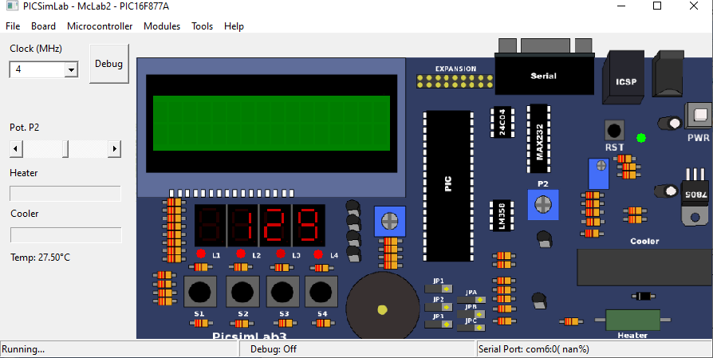

**Figure 1.** Most significant 8-bit of the analog to digital conversion result is shown on 3 displays.

**Important Note:** This task will be implemented in C programming language language (-100 pts otherwise).

Create a video which displays:

1. how you implemented the code so that it handles the most significant 8-bits of the result of the analog to digital conversion (10 points)
2. the code is successfully built (compiled), (10 points)
3. the HEX output is loaded onto PICSimLab, (10 points)
4. you selected 4 MHz clock, (10 points, -100 pts otherwise)
5. the board works as described in this manual (60 points)

The video should include your video in the upright position and your voice while you are performing and explaining the above actions (-100 points otherwise). There is no need to explain the code in the video.

The video filename and source code filename should be named as follows:

Microprocessors_Lab_5_StudentNumber_Name_Surname.mp4

Microprocessors_Lab_5_StudentNumber_Name_Surname.c

*Example:*

*Microprocessors_Lab_5_69284571_Mehmet_Kocaturk.mp4*

*Microprocessors_Lab_5_69284571_Mehmet_Kocaturk.c*

Please only upload the video file and .c file into Microsoft Teams assignment.